ConoscopeSdk CaptureSequence

|  |  |
| --- | --- |
| Abstract | The aim of this document is to describe the capture sequence |
| Version | 0.1 |
| Status | Draft |
| Date | 2020/04/06 |
|  |  |
|  |  |
|  |  |

Table of contents

1 Introduction 2

2 Exposure time configuration 2

2.1 AutoExposure 2

2.2 Manual Exposure 2

2.3 Exposure file 3

# Introduction

# Exposure time configuration

Capture Sequence exposure time has 3 configurations:  
- AutoExposure  
- All the capture have the same exposure time  
- Exposure time are defined in a json file

## AutoExposure

Check “autoExpo” so the exposure is calculated during the capture processing

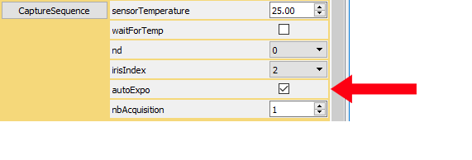

## Manual Exposure

Uncheck “autoExpo” and uncheck “useExpoFile”

Set exposure time in “exposureTimeUs” control.

All the captures are done with this exposure time

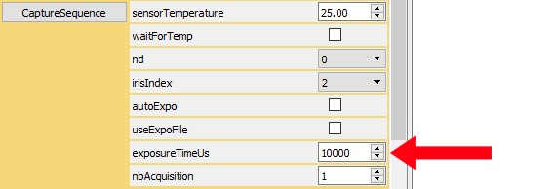

## Exposure file

Uncheck “autoExpo” and check “useExpoFile”

File “CaptureSequenceExposureTime.json” is used to retrieve the exposure time

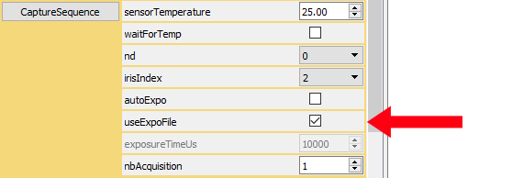

If “CaptureSequenceExposureTime.json” does not exist, it is created with default values.

CaptureSequenceExposureTime.json example:

{

"ExposureTimeUs": {

"Filter_X": 10001,

"Filter_Xz": 10002,

"Filter_Ya": 10003,

"Filter_Yb": 10004,

"Filter_Z": 10005

}

}